State of New Mexico - OSAP

State Level

2017 ANNUAL SFS High School Results

(NOT YET COMPLETE)

Youth-Targeted Goal and Objectives:

Goal 1: Reduce underage drinking in New Mexico.
Objective 1: Reduce social access to alcohol by minors 12 to 18 by…(increasing perception of risk of being caught; increased law enforcement efforts,
Objective 2: Reduce retail access to alcohol by minors 12 to 18 by… (increasing perception of risk of being caught; increasing SID checks of retailers and increasing retail education, server training, etc.)
Goal 2: Reduce binge drinking among youth 12 to 18 in New Mexico.

Goal 3: Reduce drinking and driving among youth 12 to 18 in New Mexico.

Goal 4: Reduce prescription pain killer misuse and abuse among youth 12 to 18 in NM.

Program Setting (includes community and school(s) description):

Brief Sample Description (include how school(s) and sample were selected and data were collected):

Table 1 describes the overall sample or the sample broken down by biological sex.

Table 1a: Demographics for participants by biological sex
 | Overall | Boys | Girls
Number of participants | 3811 | 1938 | 1833
Age
Mean | 15.9 | 15.9 | 15.8
Range | 12-18 | 12-18 | 12-18
 | n | % | %
12 | 14 | 0.4 | 0.2
13 | 15 | 0.4 | 0.4
14 | 517 | 12.4 | 14.7
15 | 1017 | 25.2 | 28.4
16 | 1017 | 27.4 | 26.3
17 | 817 | 22.7 | 20.5
18 or over | 401 | 11.5 | 9.5
Grade
8th grade | 34 | 1.0 | 0.8
9th grade | 1165 | 29.8 | 31.5
10th grade | 1017 | 25.8 | 28.0
11th grade | 933 | 25.8 | 23.6
12th grade | 636 | 17.6 | 16.1
Race/Ethnicity
White | 1076 | 29.4 | 27.3
Hispanic | 2329 | 59.0 | 63.9
Native American | 136 | 4.2 | 2.8
Other | 270 | 7.3 | 6.0
Language Other than English Spoken Often at Home
Yes | 1275 | 32.7 | 34.9
Identify as LGBT
Yes | 357 | 6.0 | 14.0
Have a long-term disability
Yes | 454 | 10.3 | 17.3
Number of Spanish Surveys | 14

Table 1b: Parental education level
Parents education level | %
Parents education level | Mother (n=3766) | Father (n=3770)
Not sure | 16.4 | 23.7
Some high school or less | 13.2 | 14.9
High school or Some college | 43.1 | 43.4
College and above | 27.2 | 18.0

Table 2 captures the percentage of participants self-reporting any past 30-day substance use overall and by sex.

Table 2: Past 30-day ATOD useª overall and by sex
Substance | Total valid | Overall |  | Total valid | Boys |  |  | Total valid |  | Girls
Substance | N | n^{b} | % | N | n^{b} | % | N |  | n^{b} |  | %
Current Cigarettes Use | 3763 | 348 | 9.2 | 1921 | 209 | 10.9 | 1815 |  | 136 |  | 7.5
Current Chewing Tobacco  Use | 3751 | 273 | 7.3 | 1917 | 228 | 11.9 | 1808 |  | 41 |  | 2.3
Current Hookah use | 3720 | 301 | 8.1 | 1899 | 171 | 9.0 | 1796 |  | 127 |  | 7.1
Current E-cigarettes Use | 2860 | 786 | 27.5 | 1507 | 472 | 31.3 | 1335 |  | 308 |  | 23.1
Current Alcohol Use | 3748 | 887 | 23.7 | 1916 | 439 | 22.9 | 1806 |  | 444 |  | 24.6
Current Binge Drinking^{c} | 3748 | 432 | 11.5 | 1914 | 221 | 11.5 | 1808 |  | 209 |  | 11.6
Current Extreme Binge  Drinking^{d} | 3732 | 234 | 6.3 | 1909 | 134 | 7.0 | 1797 |  | 98 |  | 5.5
Current Marijuana Use | 3742 | 902 | 24.1 | 1912 | 480 | 25.1 | 1804 |  | 416 |  | 23.1
Un-prescribed Rx  Stimulant Use | 3744 | 173 | 4.6 | 1914 | 91 | 4.8 | 1804 |  | 80 |  | 4.4
Current Rx Painkiller Use  to Get High | 3696 | 187 | 5.1 | 1889 | 96 | 5.1 | 1782 |  | 89 |  | 5.0
ªDichotomous substance use variable (yes or no).
^{b} n= number of positive responses
^{c} Binge Drinking is reported here as having consumed five or more drinks in a row at least once in the past 30 days.
^{d} Extreme binge drinking is defined here as having consumed 6 or 7 or more drinks in a row at least once in the past month.

For some substance use questions, participants could select from several responses the typical number of days or times a substance was used by the individual in the past month, from zero days to 30 days. Table 3 reports the most frequently selected category for days-of-use of each substance along with the actual percent that reported among only those who reported any use (those reporting zero days were excluded from the count). In other words, among current ATOD users, the frequency of daily use most often reported by participants is indicated in the second column and the corresponding percent is reported in the third column.

Table 3. Most frequently selected (mode) days-of-use or times-of-use category of past ATOD use among current users
Substance | Category with highest % | %
Number of Days-of-Use
Current Cigarette Use (users n=348) | 1-2 days | 31.9
Current Chewing Tobacco Use (users n=273) | All 30 days | 36.3
Current Hookah Use (users n=301) | 1-2 days | 46.8
Current E-cigarettes Use (users n=786) | 1-2 days | 45.3
Current Alcohol Use (users n=887) | 1-2 days | 57.5
Current Binge Drinking (users n=432) | 1 day | 42.4
Number of Times-of-Use
Cigarettes per day (users n=337) | 2 to 5 cigarettes per day | 32.6
Current Marijuana Use (users n=902) | 1 or 2 times | 32.8
Current Un-prescribed Rx stimulant Use (users n=173) | 1 or 2 times | 49.7
Current Rx Painkiller use to get high (users n=187) | 1 or 2 times | 53.5
Note. If there are ties, then enter all tied categories.

Figure 1. Alcohol access in the past 30 days (n=948).
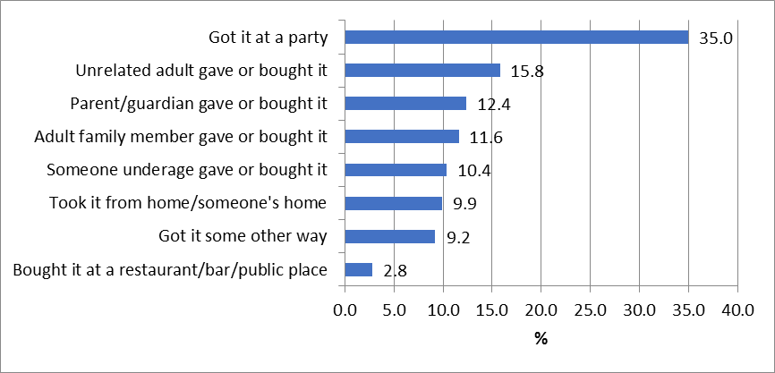
Note. The total respondents for this question differ from the number of respondents who reported current alcohol use because missing cases in the current alcohol use question are included in this question.
Figure 2. Tobacco access last 30 days (n=1184)
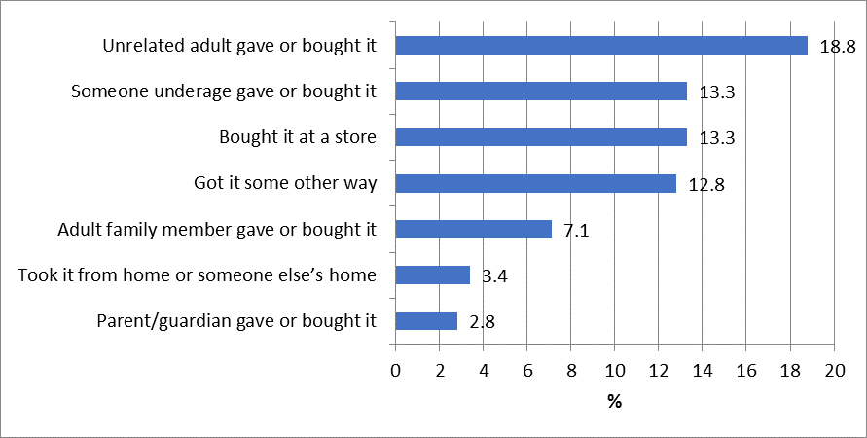
Note. The total respondents for this question differ from the number of respondents who reported smoking in the past 30 days because this question refers to all tobacco products including cigarettes, e-cigarettes, and chewing tobacco.

Table 4 provides the percentage of participants who perceive that if they were drinking alcohol at school or in their community that it is very or somewhat likely they would get caught and face consequences from the school or police.

Table 4. Percent of participants reporting that it is likely or very likely that they will be caught and face consequences if drinking alcohol at school or in the community
 | % reporting likely or very likely
Perception of risk of getting caught and facing consequences | Overall | Boys | Girls
Likelihood of being caught by teachers or staff when drinking alcohol at school (n=3727) | 59.8 | 58.2 | 61.4
Likelihood of getting into trouble with school if caught drinking at school (n=3721) | 86.1 | 85.4 | 86.9
Likelihood of being caught by police when drinking alcohol in the community (n=3713) | 43.9 | 42.7 | 45.1
Likelihood of getting arrested or cited by police if caught drinking alcohol in the community (n=3730) | 60.6 | 58.8 | 62.5

Figure 3. Prescription painkiller sources in the past 30 days (n=642)
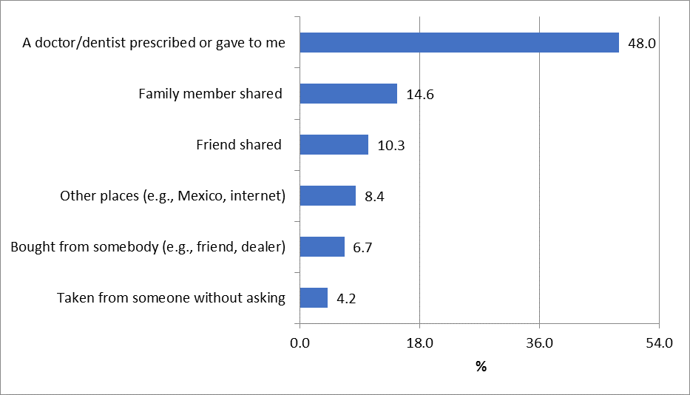
Note. The total respondents for this question differ from the number of respondents who reported used un-prescribed stimulant due to inconsistent wording across these questions therefore the number of this question is derived from the question “I didn’t use prescription pain killers in the last 30 days”.

Table 5 provides prevalence of participants who report using substances on school property during the school year and who report being offered or sold drugs on school campus during the school year.

Table 5: Prevalence of substance use and availability of drugs on school property during the school year.
Substance (Total N =3811) |  | %
Substance (Total N =3811) | Overall | Boys | Girls
Use on School Property
Cigarettes | 5.4 | 6.4 | 4.4
Chewing Tobacco | 6.6 | 10.4 | 2.6
Alcohol | 7.5 | 7.3 | 7.8
Marijuana | 10.5 | 11.0 | 10.0
Prescription Drugs to Get High | 5.2 | 5.0 | 5.2
Offered or Sold on School Property
Illegal Drug | 24.8 | 24.6 | 25.1
Prescription Drugs | 14.5 | 14.3 | 14.8

Table 6a shows the prevalence of participants who perceive moderate or great risk of harm associated with ATOD use.

Table 6a. Perceived risk of harm associated with ATOD use
Risk of harm (Total N=3811) | Moderate or great risk (%)
Smoke one or more packs of cigarettes per day | 79.5
Use e-cigarette on a daily basis | 44.4
Smoke marijuana once a month or more | 35.5
Smoke marijuana once or twice a week | 45.2
Have one or two drinks of an alcoholic beverage nearly every day | 63.2
Have five or more drinks of an alcoholic beverage once or twice a week | 71.4
Use Rx painkillers for non-medical reason | 77.8

Table 6b provides the percent of participants who agree that their parents would feel that it was very or somewhat wrong for participants to drink alcohol regularly and the percent of participants who agree that it is wrong or very wrong for participants their age to drink alcohol regularly. The table also includes the percent of participants who indicate that they engaged in risky behavior regarding personal safety.

Table 6b: Parents and youth attitudes towards ATOD use.
Attitudes Toward ATOD Use | % Feeling wrong or very wrong
Parents feel wrong for me to drink alcohol regularly (n= 3760) | 83.9
I think it is wrong for someone my age drink alcohol regularly (n=3762) | 70.3
Personal Safety in the Past 30 Days | % of Yes
Ride a car driven by someone who had been drinking alcohol (n=3759) | 16.4
Drive a car when you had been drinking alcohol (n=3764) | 5.6

Figures 4 & 5 show the percentage of youth who reported recognizing real and fictitious media campaigns to address youth ATOD use. Two of these campaigns are real. These are: “Parents Who Host Lose the Most” and “A Dose of Reality.” If prevention programs are promoting one or both of these campaigns, the percentages should increase over time. If prevention messages for “A Dose of Reality” are being correctly interpreted then, increased exposure should lead to greater understanding of the prevention. Please note that Figure 5 only includes students who select one interpretation of “A Dose of Reality”.

Figure 4. Reported percentage of media campaigns recognized by participants (n=3811)
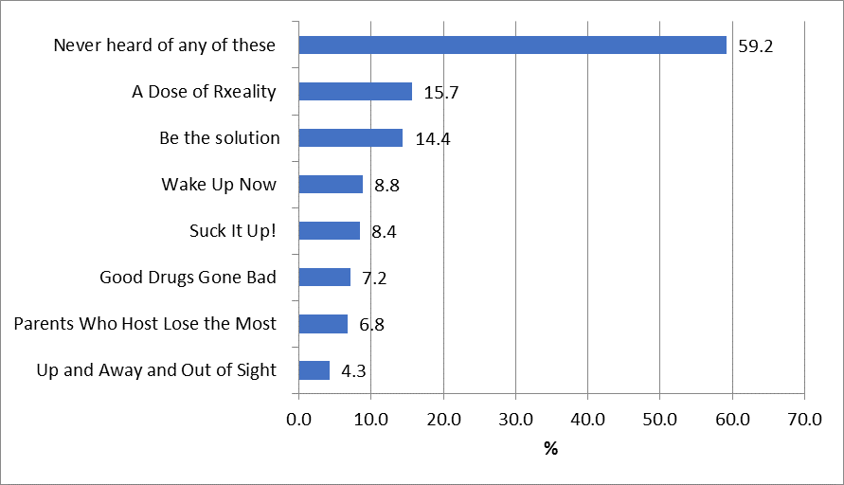

Figure 5. Reported percentage of media campaign messages interpreted by participants (Note that this only includes students who select one interpretation of “A Dose of Reality”) (n=3504)
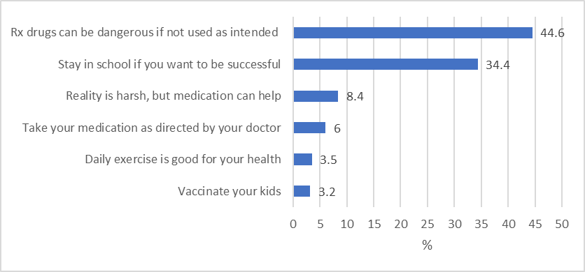
Discussion of Findings for Module A

Consider the following statements & questions as prompts only. You may remove these and summarize the information & findings you feel are most important to communicate to OSAP.

- Note any observed trends or changes in demographics that might affect your results. (e.g., predominantly girls, predominantly younger, one SES etc.) (Table 1a & 1b) Is this a representative sample of students in your community? Why or why not? How might it influence your results?

- Reflect on the prevalence and frequency of ATOD use in your sample. (Tables 2 & 3) Does the prevalence seem high, low, or about right? Why? How does it compare with similar estimates from the YRRS? If your estimates are very different from the YRRS, why might that be?

- How is the perception if risk of getting caught by law enforcement and facing legal consequences (Table 4) associated with prevalence of use do you think? (You can run a correlation between the measures to see for sure.) What about the perceived risk of harm (Table 6a)? Do participants perceive a low risk of harm and greater use or do they report a high risk of harm and still use? Similarly, attitudes reported on in Table 6b may be associated.

- Describe substance use and availability on school property during the school year (Table 5) and how it relates to the perceived risk of being caught and getting in trouble (Table 4). Are they related? Can there be improvement? What might be done to address the use and/or the perception of risk associated with it?

- Describe participants’ access to alcohol on Figures 1 and how your prevention efforts are addressing social access to alcohol. What is the most common way that minors access Rx drugs according to Figure 3?

- What implications can be drawn about the prevention efforts taking place based on these results? Are there areas where you can see room for improvement? How might you address them as a coalition? Do some IVs stand out as more critical than others for prioritization?

- Are there additional results & issues that are not represented in the tables that should be mentioned and brought to the attention of OSAP?

